Experiment Report 2

Experimental requirements and objective
- Be able to code, assemble, and execute a program with Visual C++ and MASM.
- Know how to link your programs to an external code library.
- Know how to create conditional and looping structures using assembly language.

Experimental environment
- Hardware environment
The microcomputer CPU more than Pentium, more than 120GB capacity hard drive, more than 1GB of memory.
- Software environment
Visual Studio 2008 and above versions of applications.

Experimental contents
- Write a procedure that takes three arguments: a character and two integers. The character is to be printed. The first integer specifies the number of times that the character is to be printed on a line, and the second integer specifies the number of lines that are to be printed. Write a program that makes use of this procedure.
- Write a procedure that sets each element in an array to the sum of the corresponding elements in two other arrays. (That is, if array 1 has the values 2 , 4 , 5 , and 8, and array 2 has the values 1 , 0 , 4 , and 6, the function assigns array 3 the values 3 , 4 , 9 , and 14 . ) The procedure should take each address of the three arrays and the array size as arguments. Test the procedure in a simple program.
- (OPTIONAL) Write a program that prompts the user to enter three sets of five integer numbers each. (You may assume the user responds correctly and doesn’t enter non-numeric data.) The program should accomplish all of the following:
a. Store the integers in a 3×5 array.
b. Compute the average of each set of five values, and display the results.
c. Compute the average of all the values, and display the results.
d. Determine the largest value of the 15 values, and display the results.
Each major task should be handled by a separate procedure.

4. Experiment Result

Screenshots of program execution:

a) Content one:

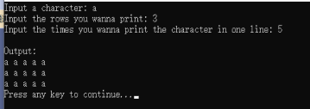

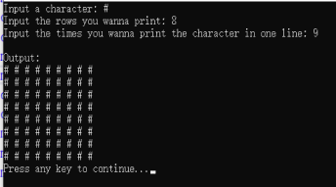

b) Content two:

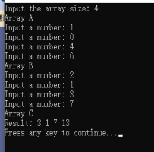

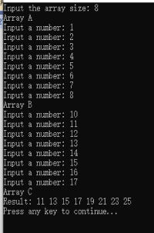

c) Content three:

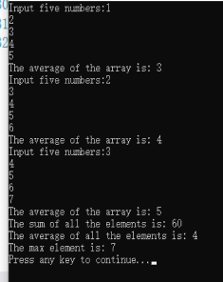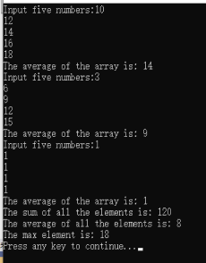

5. Source Code of Programs

title One
INCLUDE Irvine32.inc

.data
col dword ?
row dword ?
character byte ?
hInput byte "Input a character: ",0
cInput byte "Input the times you wanna print the character in one line: ",0
rInput byte "Input the rows you wanna print: ",0
Output byte "Output: ",0
.code
main proc
mov edx,offset hInput
call WriteString
call ReadChar
mov character,al
call WriteChar
call Crlf
mov edx,offset rInput
call WriteString
call ReadDec
mov col,eax
mov edx,offset cInput
call WriteString
call ReadDec
mov row,eax
mov ecx,0
mov edx,0
call Crlf
mov edx,offset Output
call WriteString
call Crlf
mov edx,0
.while ecx < col
.while edx < row
mov al,character
call WriteChar
mov al,' '
call WriteChar
inc edx
.endw
mov edx,0
call Crlf
inc ecx
.endw
call WaitMsg
main endp
end main
title Two
INCLUDE Irvine32.inc

.data
ArraySize dword 0
ArrayA dword 20 DUP(0)
ArrayB dword 20 DUP(0)
ArrayC dword 20 DUP(0)
ArrA byte "Array A",0
ArrB byte "Array B",0
ArrC byte "Array C",0
InputSize byte "Input the array size: ",0
InputNum byte "Input a number: ",0
Output byte "Result: ",0

.code
main proc
mov edx,offset InputSize
call WriteString
call ReadDec
mov ArraySize,eax
mov ecx,0
mov esi,0
mov edx,offset ArrA
CALL WriteString
call Crlf
mov edx,offset InputNum
.while ecx < ArraySize
call WriteString
call ReadDec
mov ArrayA[esi],eax
inc ecx
add esi,4
.endw
mov ecx,0
mov esi,0
mov edx,offset ArrB
CALL WriteString
call Crlf
mov edx,offset InputNum
.while ecx < ArraySize
call WriteString
call ReadDec
mov ArrayB[esi],eax
inc ecx
add esi,4
.endw
mov ecx,0
mov esi,0
mov edx,offset ArrC
CALL WriteString
call Crlf
mov edx,offset InputNum
.while ecx < ArraySize
mov eax,ArrayA[esi]
add eax,ArrayB[esi]
mov ArrayC[esi],eax
inc ecx
add esi,4
.endw
mov ecx,0
mov esi,0
mov edx,offset Output
call WriteString
.while ecx < ArraySize
mov eax,ArrayC[esi]
call WriteDec
mov al,' '
call WriteChar
inc ecx
add esi,4
.endw
call Crlf
call WaitMsg
main endp
end main
title three

INCLUDE Irvine32.inc

.data
ArrayA dword 5 Dup(0)
ArrayB dword 5 Dup(0)
ArrayC dword 5 Dup(0)
avgA dword 0
avgB dword 0
avgC dword 0
Num dword 5
hInput byte "Input five numbers:",0
hOutput byte "The average of the array is: ",0
AllOutput byte "The average of all the elements is: ",0
AllSum byte "The sum of all the elements is: ",0
max dword 0
maxOne byte "The max element is: ",0
.code
main proc

IA:
mov ecx,0
mov esi,0
mov edx,offset hInput
call WriteString
.while ecx< 5
call ReadDec
mov ArrayA[esi],eax
.if eax > max
mov max,eax
.endif
add avgA,eax
sar esi,2
inc ecx
.endw
jmp AvgAA
IB:
mov ecx,0
mov esi,0
mov edx,offset hInput
call WriteString
.while ecx< 5
call ReadDec
mov ArrayB[esi],eax
.if eax > max
mov max,eax
.endif
add avgB,eax
add esi,4h
inc ecx
.endw
jmp AvgAB
IC:
mov ecx,0
mov esi,0
mov edx,offset hInput
call WriteString
.while ecx< 5
call ReadDec
mov ArrayC[esi],eax
.if eax > max
mov max,eax
.endif
add avgC,eax
add esi,4h
inc ecx
.endw
jmp AvgAC

AvgAA:
;call WriteDec
mov edx,0 ;这里必须清零，else会出bug
mov eax,avgA
mov esi,5
div esi
mov edx,offset hOutput
call WriteString
call WriteDec
call Crlf
jmp IB

AvgAB:
;call WriteDec
mov edx,0 ;这里必须清零，else会出bug
mov eax,avgB
mov esi,5
div esi
mov edx,offset hOutput
call WriteString
call WriteDec
call Crlf
jmp IC

AvgAC:
;call WriteDec
mov edx,0 ;这里必须清零，else会出bug
mov eax,avgC
mov esi,5
div esi
mov edx,offset hOutput
call WriteString
call WriteDec
call Crlf

SumAvg:
mov eax,avgA
add eax,avgB
add eax,avgC
mov edx,offset AllSum
call WriteString
call WriteDec
call Crlf
mov edx,0
mov esi,15
div esi
mov edx,offset AllOutput
call WriteString
call WriteDec
call Crlf

TheMax:
mov edx,offset maxOne
call WriteString
mov eax,max
call WriteDec
call Crlf

call WaitMsg
main endp
end main
6. Summary

Preparations:
For the whole experiment, since we have already prepared the environment, we can start to programming with the knowledge below:
- How the data is stored in the array using assembly language
- Branch ( .if & .endif ) and loop ( .while & .endw )
- Multiplication and division ( with one register or memory, cannot use the instant number )

Writing the program:
a) For the content one, we can turn the requirements into the following contents:
- Input a character, it needs to be printed in the screen by calling procedure “WriteChar”
- Input two character, one is representing how many rows of the line will the procedure print, the other is representing how many characters will be printed in one single line.
- Using while loop to print the array of the character

Register inside:
- Edx → Output the string & Inner loop iterator
- Eax → Transformation of the number for the input and output
- Ecx → Outer loop iterator
- Al → Store the character and output the character

Variables inside:
- Col → Store the column number
- Row → Store the row number
- Character → Store the character which will be repeatedly printed

In order to give a friendly interface, we add some strings:
- hInput → “Input a character”
- cInput → “Input the times you wanna print the character in one line”
- rInput → “Input the rows you wanna print”
- Output → “Output”

b) For content two, we can turn the requirements into the following content:
- Declare three arrays with same sizes, two for storing the input numbers, another one for sum of the corresponding elements of the arrays.
- Declare a variable for storing the size of the arrays.
- Loops for number inputs and sum the corresponding elements.

Register inside:
- Edx → Output the string
- Eax → Transformation of the number for the input and output
- Ecx → Loop iterator
- Esi → Index for the arrays
- Al → Store the character and output the character

Variables inside:
- ArrayA & ArrayB → Storing two sets of the numbers
- ArrayC → Storing the sum of the corresponding elements
- ArraySize → Storing the size of the arrays

In order to give a friendly interface, we add some strings:
- ArrA → “Array A”
- ArrB → “Array B”
- ArrC → “Array C”
- InputSize → “Input the array size”
- InputNum → “Input a number”
- Output → “Result”

c) For content three, we can turn the requirements into the following content:
- Declare three arrays to store the data and the size is five
- Calculate the average of each array and the average of total elements by using div instruction
- Find the maximal number by using branch.

Registers inside have the same function as content two.

Variables inside:
- ArrayA & ArrayB & ArrayC → Store the data
- avgA & avgB & avgC → Store the average number of the array respectively
- Num → Divisor
- Max → Maximal number

In order to give a friendly interface, we add some strings:
- hInput → “Input five numbers”
- hOutput → “The average of the array is”
- AllOutput → “The average of all the elements is”
- AllSum → “The sum of all the elements is”
- maxOne → “The max element is”

In conclusion:
- Since we use the “dword” type variable, when we do the iteration, the index need to be increased by four.
- Carefully using the mul/div instruction: They are the unary instruction, and the operand cannot be the instant number. In addition, we need to initialize the edx register with the number zero when we do the division since we use the “dword” type variable. If we do not initialize the edx register, the compiler will pass code but the code will fail to run correctly since integer overflow occurs.

